中新国际联合研究院
自立科研项目重要事项变更申请表
Sino-Singapore International Joint Research Institute (SSIJRI)
Project Change Request Form

基本信息 General Information
申请日期Application date | 点此选择日期Click to choose a date | 项目编号  Project No.
项目名称
Project Title
项目所属平台
Platform
申请人
Applicant
项目起止年月  Project Start and End Date | From (YYYY年/MM月/DD日) to (YYYY年/MM月/DD日)
项目进展简述
Briefly describe project progress up to date

申请变更内容Change Request
 | 当前情况  Current State | 申请变更为  Proposed Change | 变更理由及说明  Reason for Change and Specifications
更换项目负责人¹  PI Change |  |  | - 理由和说明Reason and Specifications：  - 请在文件后附新项目负责人简历Please attach CV of new PI to the form  - 新负责人签名Signature of New PI:
更换项目名称
Project Title Change
更换项目组成员  Team Member Change |  |  | - 理由和说明Reason and Specifications：  - 新成员在项目中的分工Role of the new team member in the project:  - 请在文件后附新成员简历Please attach CV of new team member to the form  - 所有项目组成员签名Signature of ALL team members:
调整项目预算²  Budget Adjustment |  |  | - 理由和说明Reason and Specifications：  - 请提交”项目经费预算调整申请表“  Please submit the “budget adjustment request form”
项目时间调整(延期或提前结束)³  Extension or early termination |  |  | - 理由和说明Reason and Specifications：  - 请在文件后附项目新的进度安排Please attach project new schedule to the form
项目内容调整
Project Content Change
项目成果调整
Deliverables Change
申请撤项
Project Withdrawal
其他
Others

- 新项目负责人尽量为原课题组成员It is recommended that new PI is a current team member.
- 经费调整需遵循在“项目预算经费调整申请表”中所列原则要求：
The budget adjustment shall follow the rules indicated in the “budget adjustment request form”
- 项目仅可申请一次延期，不得超过项目周期的50%，延期后整个项目周期不得超过三年
All projects can only request for project extension once, and the extension shall not exceed 50% of the project duration. The entire project duration shall not exceed 3 years after extension.

审批Approval
项目负责人意见Comment by Project Investigator

签名Signature |  | 日期Date(YYYY/MM/DD)
创新发展部意见Comment by Innovation Development Department

签名Signature |  | 日期Date(YYYY/MM/DD)
院长意见Comment by Director

签名Signature |  | 日期Date(YYYY/MM/DD)

1.项目进度和阶段目标Project Execution Plans and Milestones

1.1项目进度计划 Execution Plan
请将项目进度计划以流程图的形式填写，其中包括主要科研活动和阶段目标。请参照下方示例图Please present your execution plan using a flow chart, which shall include key activities and milestones. An example is provided below as an illustration:

示例Example
项目名称：创新测试仪的研发Project title: Development of an innovative tester
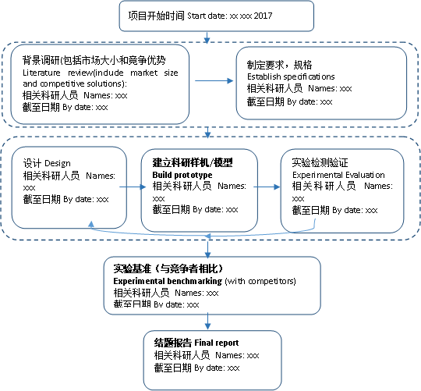
备注Remark：加粗的是阶段目标milestones in bold font

1.2项目阶段内容及产出Task and Deliverables
请注明项目各阶段的主要内容及产出。Please summarize task and deliverables for each phase
阶段Phase | 时间  Time | 项目主要内容  Project tasks | 目标  Deliverables | 资金使用%  % Fund allocation

